Ancient Egypt
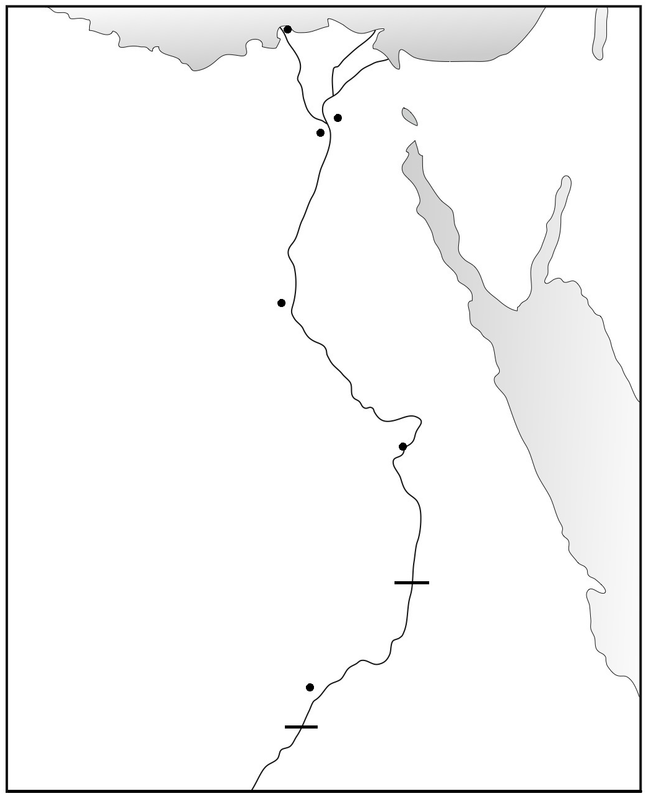

Label the cities:
Alexandria
Amarna
Cairo
Memphis
Abu Simbel
Thebes/Luxor

Label the geography:
Delta
Mediterranean Sea
Nile River
Red Sea
Sinai Peninsula
Suez Canal

Aswan Dam
Lake Nasser
1st Cataract
Second Cataract
Upper Egypt
Lower Egypt

