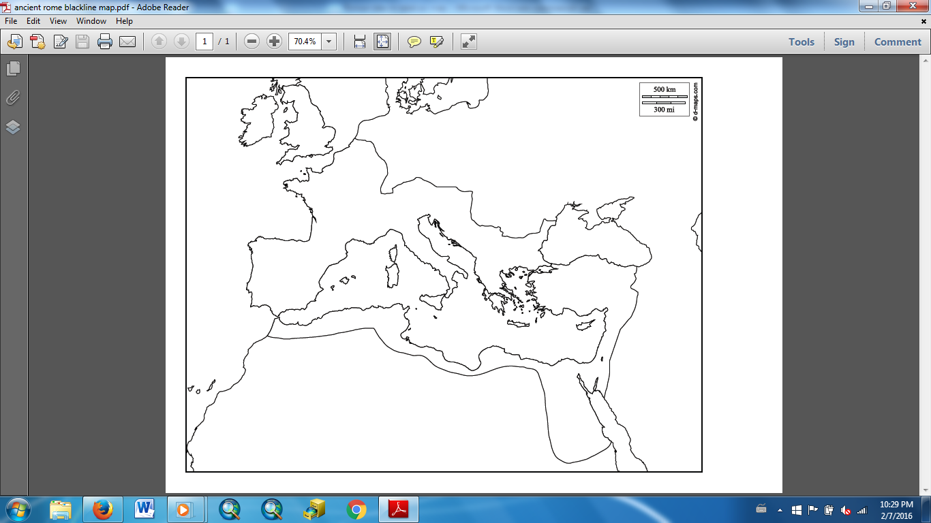



**Roman Empire in 116 CE**

**Water**

**Land**

**Roman Empire**

Adriatic Sea

Alps

Apennines

Britain

Carthage

Corsica

Egypt

Greece

Hadrian’s Wall

Ionian Sea

Mediterranean Sea

Mesopotamia

Mt. Etna

Mt. Vesuvius

Rome

Sardinia

Sicily

Tyrrhenian Sea

Pompeii

Po River

Tiber River

Rubicon River