Aztec Ball Game
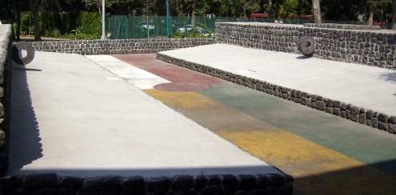
Let me ask you this - if you move into a new home, what do you do first? Set up your bed? Put up a special picture? Plug in the stereo? When the Aztecs started a new settlement, there were two things they would do. First, build a shrine to the god Huitzilopochtli, and then build a ball court next to it. In the Aztec capital city, Tenochtitlan, the center of the city was the ball court, the palace, and the temple. The Aztec ball game, known as ullamaliztli, was a priority.
Left: A sample ullamaliztli tlachtli
The game is believed to have come from the Olmecs, and was also played by the Maya. The Aztec ball game had a distinctive court known as the tlachtli or tlachco. The ball court was usually in the shape of an I, although there were some variations. Around the court was a slope, surrounded at the outer edge by walls about 8-11 feet high. The court was usually between 100 and 200 feet long, with a center line, and six markers along the sloping walls. At center court against the walls were two stone-carved rings, roughly 35 inches in diameter, often ornately carved in the form of an animal.
Surrounding the court were areas for spectators, nobles and judges. There would often be skull racks (tzompantli) where the heads of past players would be posted. Sometimes the walls would show pictures of the winners and losers of the past. The ball, or ulli, was made of hard rubber and weighed about 9 pounds. Due to the rough surface of the court itself, protective gear was worn by the players. Players wore deerskin guards for the chin, hip, thigh, hands, and cheeks. Even with this protection, players would end the game bruised and bleeding, since they often had to throw themselves to the ground.

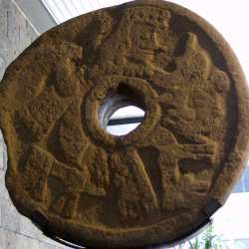
An actual ring used in the ancient Mesoamerican ball game, Ullamaliztli
The teams would face each other on the court. The object in the end was to get the ball through the stone hoop. This was extremely difficult, and so if it actually happened the game would be over. In fact, according to historian Manuel Aguilar-Morenao, some courts didn't even have rings. Another important rule was that the ball was never allowed to touch the ground. Players couldn't hold or even touch the ball with their hands - only the elbows, knees, hips and head were used. As you may imagine, this made for a very fast paced game, and the players had to constantly throw themselves against the surface of the court to keep the ball from landing. The players were skillful, and the ball could stay in the air for an hour or more.
Because it was so hard to get the ball through the hoops, there were other objects as well. Players could hit one of the six markers along the sides of the court to earn a point. Or, they would be given points for other skillful plays. Fouls were also given if the players couldn't get the ball across the center line, or if they touched the ball with the wrong part of the body, such as the hand or calf.
During the Aztec ball game, gambling was common among the spectators. Gambling reached high levels in the Aztec empire. Just about anything could be gambled, from ornate feathers to land to children. It was common for a person to actually sell themselves into slavery in order to pay off the debt. This was voluntary slavery, with some parallels to the way someone today would work at a job he or she doesn't like for years just to pay off a debt. Huge wagers might be made by kings as well. A story is told of two kings, one wagering a garden, another betting a marketplace. The marketplace was lost, but the winning king was assassinated when a group from the loser congratulated him. They gave him a garland, with a leather strangling cord hidden inside.

With city-states and tribes playing against one another, it's not surprising that the Aztec ball game took on political significance. A win or a loss was very much taken to heart. At times, the game would turn into an excuse for an assassination or attack. The game might also be used to settle differences between two parties. It is believed that the losing coach, or even the whole team, might be sacrificed. Some historians have disputed this - because it was an honor to be sacrificed, it may have been the winning team that lost their lives.

Adapted from Aztec History http://www.aztec-history.com/aztec-ball-game.html
Aztec Ball Game
- What was the first thing Aztecs would build in a new city?

- What was a tlachtli and how big was it?

- What would happen if the ulli went through the hoop? What if it hit one of the six markers along the side?

- What do you see in common with modern sports, their teams, and the effects of winning or losing?

- If you were an Aztec, would you be willing to gamble on the outcome of the game? Why or why not?

Aztec Ball Game
- What was the first thing Aztecs would build in a new city?

- What was a tlachtli and how big was it?

- What would happen if the ulli went through the hoop? What if it hit one of the six markers along the side?

- What do you see in common with modern sports, their teams, and the effects of winning or losing?

- If you were an Aztec, would you be willing to gamble on the outcome of the game? Why or why not?

