Shang Dynasty
Era Information
Time: 1700 B.C.-1027 B.C.
Location of Capital: Modern City of Anyang in Henan Province
Replaced by: Zhou Dynasty
The Shang dynasty is also called Yin dynasty by historians. Legend has it that the Shang dynasty was built by a rebel leader who overthrew the last Xia ruler (from Neolithic times). This dynasty lasted for over 600 years, after which it was replaced by the Zhou (pronounced “Joh”) family.
The Shang dynasty focused mainly on agriculture, hunting and animal domestication as they left the Stone Age era. A number of ceremonial bronze vessels with inscriptions date from the Shang period have been found, and the workmanship on the artifacts demonstrates a high level of civilization.
The Shang dynasty had two capital cities, Shang and Anyang. After the first was destroyed by invaders, the second was constructed at the site of the modern city of Anyang. These cities were centers of glittering court life, with elaborate court rituals intended to win the favor of visiting spirits and to honor sacred ancestors.
In addition to his government position, the king was also the head of the ancestor worship. Evidence from the royal tombs indicates that royal personages were buried with articles of value, presumably for use in the afterlife. Perhaps for the same reason, hundreds of peasants, who may have been slaves, were buried alive with the royal corpse.
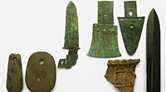
A line of hereditary Shang kings ruled over much of northern China, and Shang troops fought frequent wars with neighboring settlements and nomadic herdsmen from the inner Asian steppes.

Zhou Dynasty
Era Information
Time: 1027 B.C.-771 B.C.
Location of Capital: Hao, near the city of Xian, Shannxi Province
Emperors: Twelve kings for eleven dynasties
Replaced by: Warring States Period
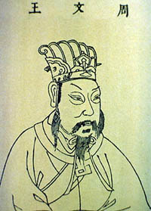
According to Chinese accounts, the Zhou dynasty was built by a chieftain of a tribe called Zhou (pronounced “Joh”). The chieftain overthrew Shang’s last ruler and began the new dynasty. The chieftain settled down in Hao (also known as Haojing), a city near today’s Xi’an city in Shannxi province.
The Zhou Dynasty was the longest dynasty in Chinese history. It lasted for over 800 years and included the reigns of 37 emperors. The Zhou Dynasty is divided into two periods: the Western Zhou Dynasty (11th century BC to 771 BC) and the Eastern Zhou Dynasty (770 BC - 221 BC). Weak leadership and invaders caused the Zhou dynasty to crumble into various smaller dynasties near the end. These smaller groups were in constant warfare, which is why the succeeding era of Chinese history is often known as the Warring States period.
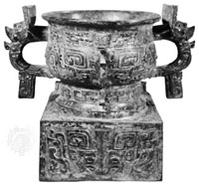
The Zhou Dynasty also had many achievements in economy, politics, science and culture which were much more illustrious than any which occurred during the Shang Dynasty. One of the philosophies that grew during the Zhou period was the idea of the “mandate of heaven.” This meant that the emperor governed by divine right. If, however, the ruler was dethroned, it was proof that he had lost the divine favor of both the people and the ancestors. Such was the case when the Zhou chieftain overthrew the Shang leader, which meant that the Shang ruler was not meant to continue as emperor. This was also used as the reason for the Zhou collapsing into various smaller groups at the end of the dynasty.

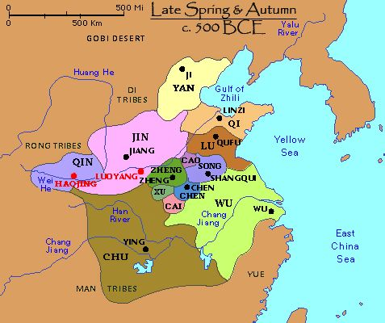
Warring States Period
Era Information
Time: 475 B.C.-221 B.C.
Location of Capital: Multiple capital cities
Emperors: Multiple emperors in multiple states
Replaced by: Qin Dynasty
In 771 B.C., the Zhou emperor was killed by invaders. Local rulers began to fight among themselves to determine who should be the next emperor. The many wars between the various states have led to the name of this era of Chinese history.
The Warring States period was a very turbulent time, but it was also a time of cultural advances. Each local ruler tried to attract the best scholars and thinkers to help him rule his state wisely. Each thinker had his own idea about the best way to rule and to bring peace and unity to China. Because there were so many ideas, this period is also called the era of the “Hundred Schools” of philosophy.
China’s most famous scholar lived during this time. His name was Kong Fu Zi, or Confucius. Confucius traveled from state to state and advised many rulers. During his travels, he attracted many students who agreed with his teachings. These students wrote down what Confucius said, and continued to teach his philosophy after his death. Confucius did not start a religion, but he did initiate a new way of thinking for Chinese people.
Another famous Chinese thinker also spread a new way of thinking during the Warring States period. Lao Zi taught that nature should guide people in their lives. His teaching became known as Daoism, or the way. Lao Zi taught that nature should guide people in their lives.

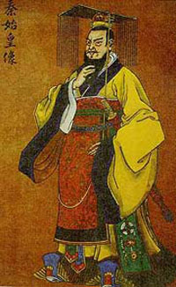
Qin Dynasty
Era Information
Time: 221 B.C.-207 B.C.
Location of Capital: Xianyang City in Shanxi Province
Emperors: Ying Zheng, Fushu, Zi Ying
Replaced by: Han Dynasty
In 221 B.C., the Chinese were unified for the first time after a long era of fighting between the Warring States. In that year the western frontier state of Qin, the most aggressive of the Warring States, defeated the last of its rival states and unified the Huang He valley.
To achieve complete unification without the risk of further uprisings, the emperors used ruthless methods to silence critics. They confiscated and burned the books of many scholars who disagreed with their methods, and executed many who continued to criticize their rule. The harsh treatment caused many of the citizens to further resent their leadership. This dynasty, however, is known for creating standardized coins and writing, the bureaucratic procedures of government, and patterns of thought and scholarship.
The Qin era is also marked by expansion through frequent military expeditions into the frontiers in the north and south.
In order to fend off barbarian intrusion, the fortification walls built by the various warring states were connected to make a 5,000-kilometer-long Great Wall. The Great Wall is actually four great walls rebuilt or extended during the Western Han, Sui, Jin, and Ming periods, rather than a single, continuous wall. At its extremities, the Great Wall reaches from northeastern Heilongjiang Province to northwestern Gansu.
A number of public works projects were also undertaken to consolidate and strengthen imperial rule. These activities required enormous levies of manpower and resources, not to mention repressive measures.
Revolts broke out as soon as the first Qin emperor died in 210 B.C. His dynasty was extinguished less than twenty years after its triumph. The imperial system initiated during the Qin dynasty, however, set a pattern that was developed over the next two millennia

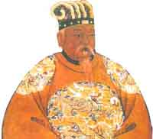
Han Dynasty
Era Information
Time: 206 B.C.-220 A.D.
Location of Capital: Chang an
Emperors: Han Wudi, Wendi, Jingdi
Replaced by: Three Kingdoms
The Han dynasty replaced the Qin dynasty through a rebellion of the peasants. Two leaders, Liu Bang and Xiang Yu struggled to take control of the Huang He valley. Liu Bang eventually defeated Xiang Yu and became the first emperor of the Han dynasty. Chang’an became the new capital during the Han Dynasty.
Building upon the base of Qin dynasty, the new empire retained much of the Qin administrative structure but created new territories governed by local leaders, which reduced the demands on the emperor’s time.
While the Qin dynasty is known for its harsh and cruel laws, the Han rulers are known for adopting the Confucian ideals of government. This resulted in a kinder government that valued education. Under the Qin, government positions were usually given to friends and relatives of the emperor. Under the Han, a testing system was established where only individuals who passed the exams were eligible for political positions. This resulted in government workers who were qualified to complete the tasks assigned to them.
The Han period produced China's most famous historian, Sima Qian (145-87 B.C.), whose historical records provide a detailed chronicle from the time of a legendary Xia emperor to that of the Han emperor Wu Di 141-87 B.C.).
Technological advances also marked this period. Two of the great Chinese inventions, paper and porcelain, date from Han times.

