quarry
(ˈkwôrē,ˈkwärē/)
noun
- a place, typically a large, deep pit, from which stone or other materials are or have been extracted.
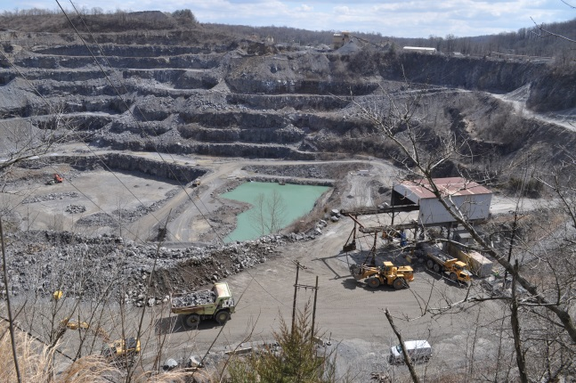

polytheism
[pol-ee-thee-iz-uh m, pol-ee-thee-iz-uh m]
noun
- the belief in more than one god or in many gods.

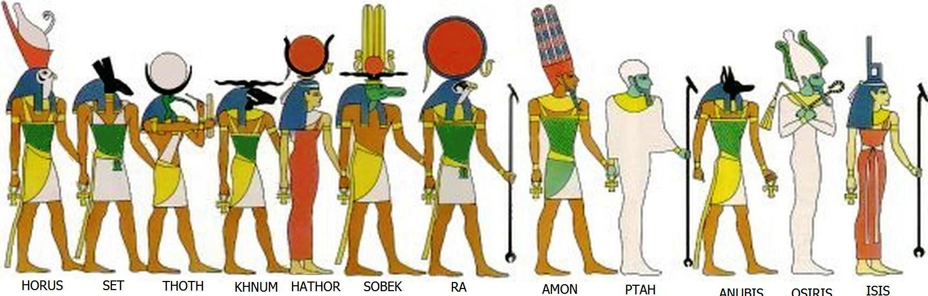

monotheism
[mon-uh-thee-iz-uh m]
noun
- the belief that there is only one God.
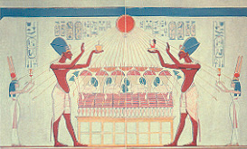

Pectoral
- an type of jewelry worn in ancient Egypt; a large necklace
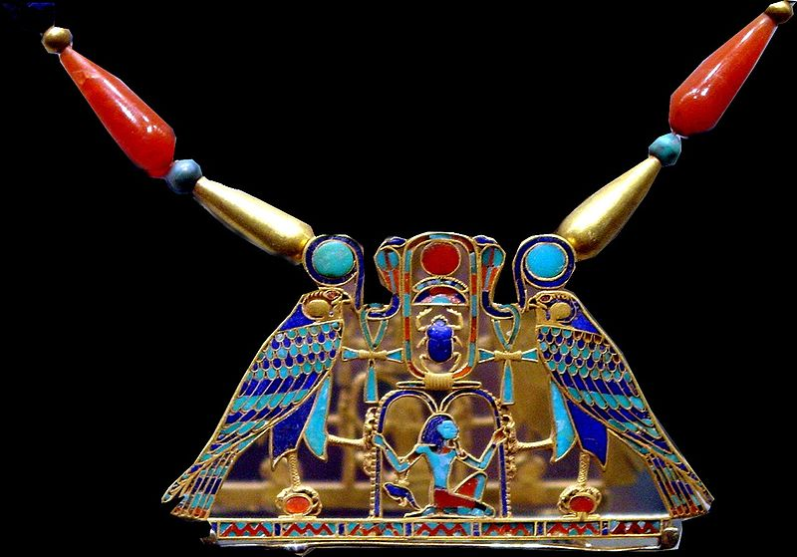

obelisk
- a stone pillar, typically square or rectangular with a pyramidal top, set up as a monument or landmark.
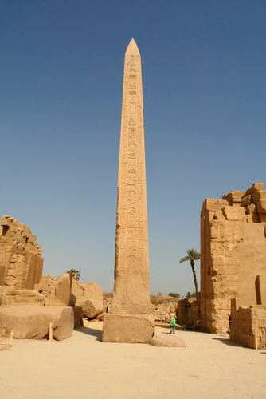

papyrus
- a water plant growing along the Nile that was used to create sheets of “paper”, rope, sandals, and boats.

sphinx
[sfingks] noun, plural sphinxes
- a figure of an imaginary creature having the head of a man or an animal and the body of a lion.
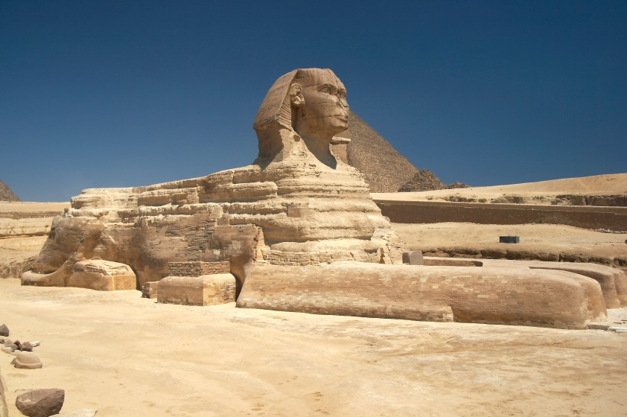
Rosetta Stone
noun
- a stone slab, found in 1799 near Rosetta, that helped historians decipher ancient hieroglyphics.
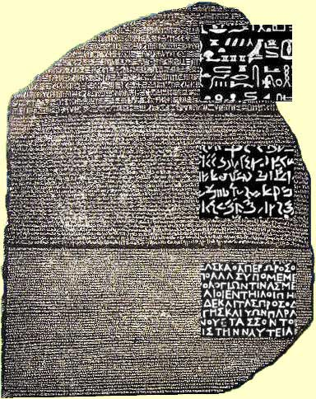

fresco
noun
- a painting done rapidly in watercolor on wet plaster on a wall or ceiling, so that the colors penetrate the plaster and become fixed as it dries.
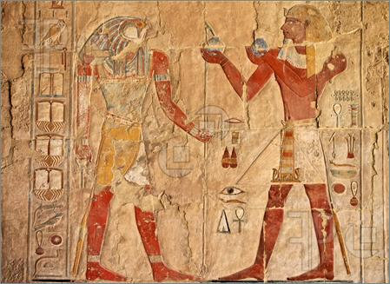

faience
- Egyptian faience (also known as Egyptian paste) is the oldest known type of glazed ceramic.
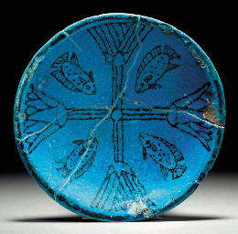

mummy
- A mummy is a deceased human or other animal whose skin and organs are not allowed to rot so that the body is preserved.
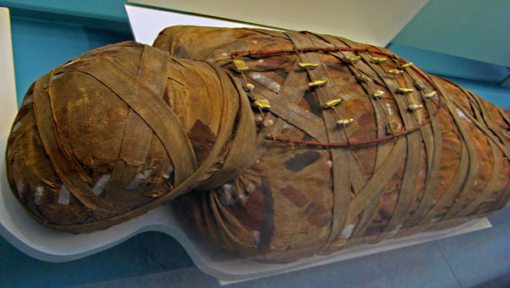

Canopic jars
- Jars used by the Ancient Egyptians during the mummification process to store and preserve internal organs. They were commonly either carved from limestone or were made of pottery.
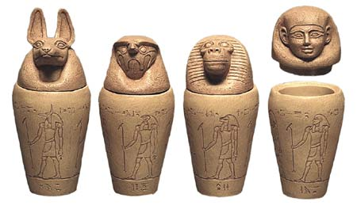

sarcophagus
särˈkäfəɡəs/
- a stone coffin, typically decorated with a sculpture or inscription.
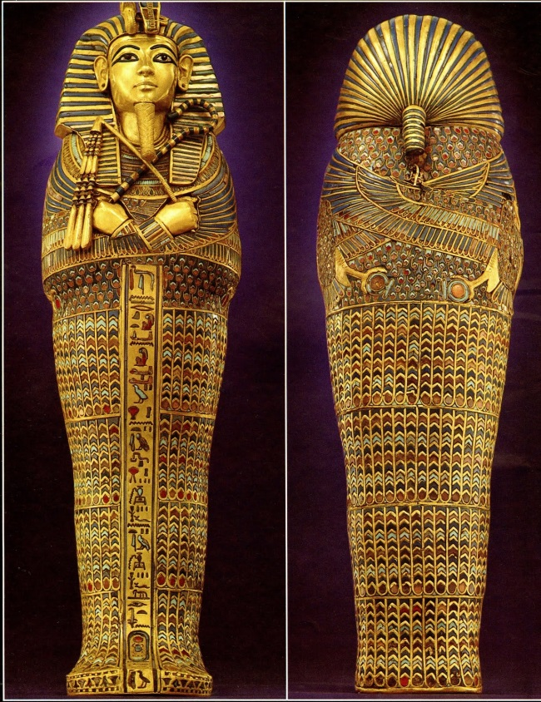
vizier
(/vɪˈzɪər/ or /ˈvɪzɪər/)
- the highest official in Ancient Egypt next to the king; an assistant pharaoh.
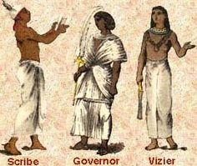

lapis lazuli
ˈlapis ˈlazəˌlē,ˈlaZHəˌlī,ˈlazyəlē/
- a bright blue metamorphic rock consisting largely of lazurite, used for decoration and in jewelry.
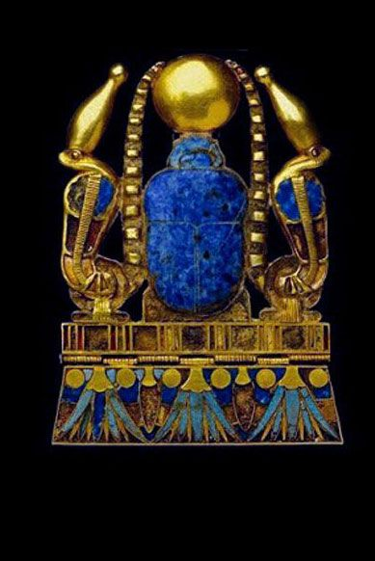
pharaoh
ˈferō/

- a ruler in ancient Egypt.
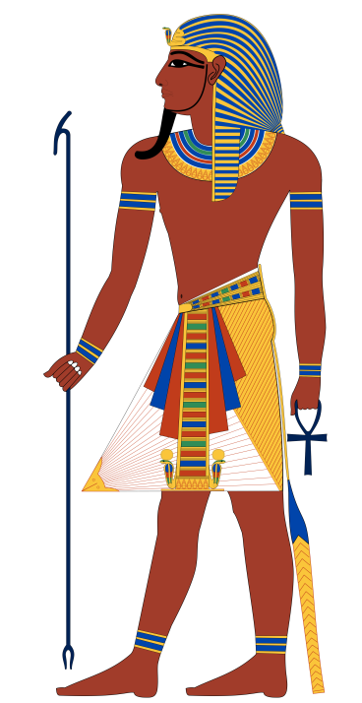

delta
- The Nile delta is the delta formed in Northern Egypt (Lower Egypt) where the Nile River spreads out and drains into the Mediterranean Sea.
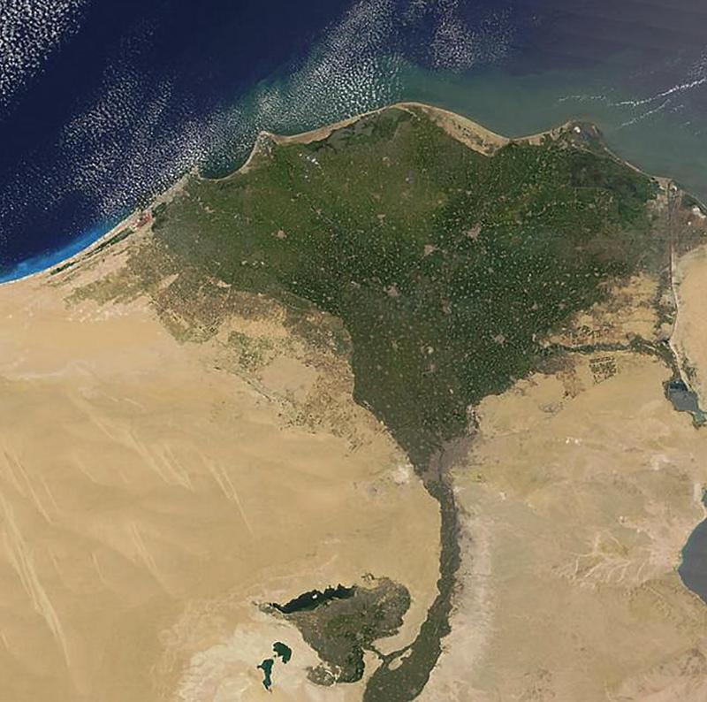
shadoof
or shaduf. [shah-doof] /ʃɑˈduf/ 1. a device used in Egypt and other Eastern countries for raising water, especially for irrigation, consisting of a long suspended rod with a bucket at one end and a weight at the other. 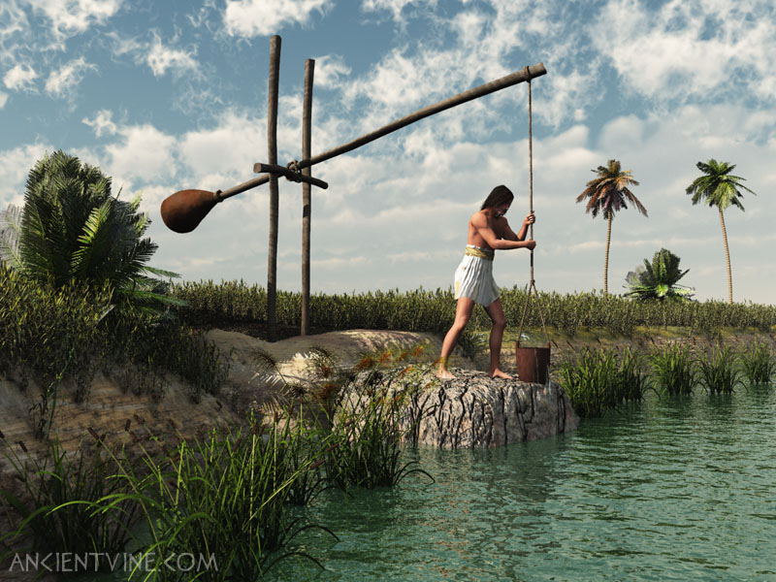

Inundation
- The yearly flooding of the Nile. The Season of the Inundation was the first season in the ancient Egyptian calendar. The Ancient Egyptians marked the beginning of their year by the rising of the Nile.
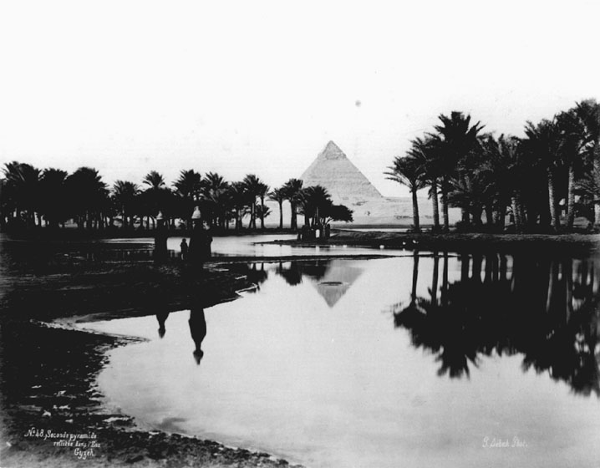
lotus
- any of a number of large water lilies, in particular. In Egypt, it represented rebirth since it would disappear at night and re-emerge in the morning. The lotus came to symbolize the Sun and the creation.

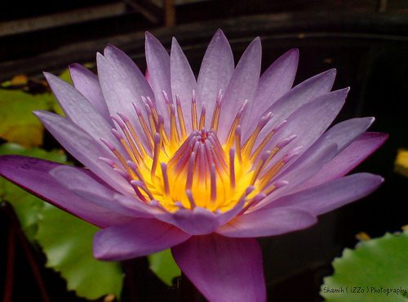
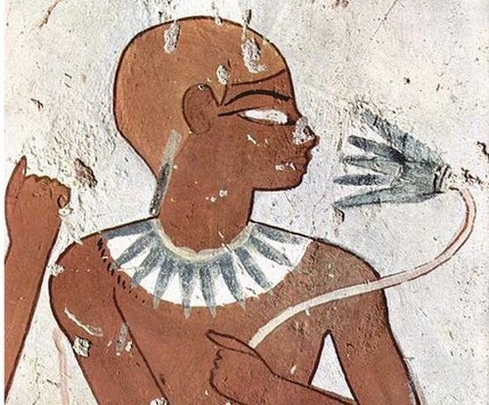

hieroglyphics
- The Egyptian writing called hieroglyphics used pictures to represent different objects, actions, sound or ideas. There were more than 700 hieroglyphs. Some pictures stood for whole words.
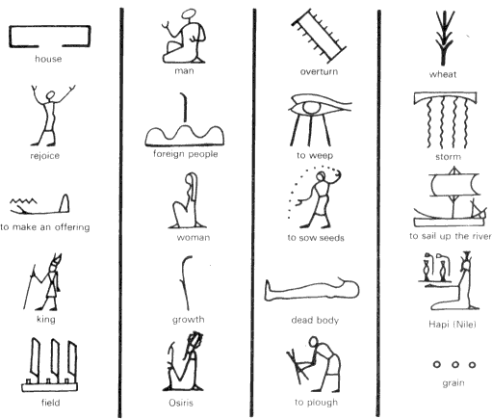
scribe
- A scribe is a person who writes books or documents by hand in hieroglyphics, cuneiform or other scripts and may help keep track of records.
