Inca Mummies
When people talk about human mummies, they are often referring to those found in ancient Egypt. However, you may be surprised to learn that mummified humans have been found on every continent. In fact, the oldest mummies in the world are not from Egypt but from the Andes region of South America. The Inca civilization and its forebears are credited with being the original mummifiers of human bodies, dating as far back as 6000 BCE.
The Inca of Peru used a process known as desiccation, or freeze-drying, to mummify many of their dead. This process used the natural climate conditions of the Andes Mountains to freeze and dry the corpse so that it wouldn’t decay. Earlier groups in the region used salt (an uncommon material) and alcohol (beer made from maize) to dry the bodies of the mummies. Both of these techniques were costly and used resources that otherwise would have been used as food, so the process was simplified to take advantage of the cold and dry desert conditions of the Atacama Desert in the high Andes. The body would be cleaned of as much fluid as possible, wrapped in cloth, and then placed on the side of a high mountain peak where the wind and cold would dry the corpse before it could decompose. They were often placed in a fetal (crouched) position, giving the appearance of someone hiding under a blanket to keep warm. Personal possessions such as jewelry, tools, or fine clothing might be included with the mummy.
Ancestor Worship
Mummification wasn’t the only type of burial used by the Incas, but was one way to show a deep reverence for older generations (ayllu) and create family connections within communities. These mummies were also seen as a link between the living and the gods, and so were often removed from their resting places and used as oracles, being asked questions about how to solve the problems their descendants were struggling with. They were also brought to local celebrations, such as marriages or harvest festivals. At the celebrations they would be seated in locations of honor and offered food and drink, often with someone assigned to make sure their needs were met.

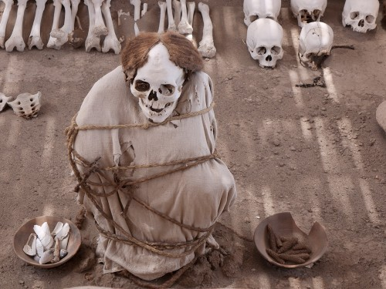
One of the most remarkable sites for mummified remains is the area around Cajatambo in the highlands of Peru. Spanish invaders recorded that no fewer than 1,825 ancient mummies were maintained in the region. Here mummies were stored in sacred caves known as machay and offered food and drink so that their descendants could be given a fruitful harvest.
Royal Mummies
After Columbus reported to the Spanish aristocracy the fabulous wealth available in the Americas, conquistadores came to conquer the native tribes and capture their treasures. Since the Catholic priests who accompanied the conquistadores interpreted the mummies to be idols, the Spanish destroyed as many of the mummies as they found. As a result, very few mummies of the aristocratic class remain today for archaeological study. According to legend, many of the royal mummies of the Inca empire were repeatedly moved around the capital city of Cuzco to avoid being captured and destroyed by the Spanish. Imagine this game of “hide and seek the mummy” to protect the Incan ancestors from the invading conquistadores! Ultimately, most mummies were discovered and destroyed in 1559 CE. One Spaniard, Garcilaso de la Vega, described them in his journal before they were destroyed:
“Their bodies were so perfect that they lacked neither hair, eyebrows nor eyelashes. They were in clothes such as they had worn when alive... I remember touching a finger of the hand of Huayna-Capac. It was hard and rigid, like that of a wooden statue. The bodies weighed so little that any Indian could carry them from house to house in his arms or on his shoulders. They carried them wrapped in white sheets through the streets and squares, the Indians falling to their knees and making reverences with groans and tears...” (D'Altroy, 97-99)

Adapted 12/2015 from Mark Cartwright’s article found at http://www.ancient.eu/article/699/
Inca Mummies
- Were the ancient Egyptians the first to mummify human bodies?

- How did ancient cultures in the Andes Mountains mummify bodies?

- Why did the Incans mummify bodies of their dead relatives?

- What happened to the mummies when the Spanish conquistadores came?

- According to Garcilaso de la Vega, how heavy were the mummies?

Inca Mummies
- Were the ancient Egyptians the first to mummify human bodies?

- How did ancient cultures in the Andes Mountains mummify bodies?

- Why did the Incans mummify bodies of their dead relatives?

- What happened to the mummies when the Spanish conquistadores came?

- According to Garcilaso de la Vega, how heavy were the mummies?
Inca Mummies
- Were the ancient Egyptians the first to mummify human bodies?

- How did ancient cultures in the Andes Mountains mummify bodies?

- Why did the Incans mummify bodies of their dead relatives?

- What happened to the mummies when the Spanish conquistadores came?

- According to Garcilaso de la Vega, how heavy were the mummies?

