Mesopotamia
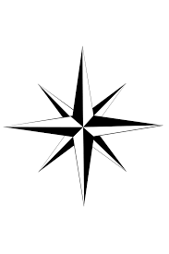

Label the following:

Cities
Sumer
Kish
Babylon
Ashur
Ninevah
Ur
Uruk
Jerusalem
Shade in the Fertile Crescent
Label the Compass Rose directions!

Landforms
Red Sea
Caspian Sea
Map Key
Water
Desert
Mountains
Fertile Crescent
Black Sea
Mediterranean Sea
Persian Gulf
Tigris River
Euphrates River
Arabian Desert
Zagros Mountains
Tarsus Mountain

