Kinich Janaab Pacal
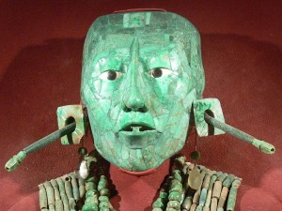
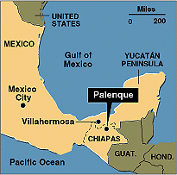
K'inich Janaab' Pacal (born 23 March 603 CE – died 31 March 683 CE) was the Maya king of Palenque in the modern-day state of Chiapas, Mexico. Also known as Pacal (which means 'shield') and Pacal the Great, he is most famous for raising the city of Palenque from relative obscurity to a great power, for his building projects in the city (especially the Temple of the Inscriptions), and his elaborately carved sarcophagus lid. Pacal became king of Palenque at the age of 12, in 615 CE, and ruled successfully until his death at the age of 80. His reign is significant because of how long he lived and ruled, placing him among the top 50 recorded monarchs in history.
Mayan scholars have deciphered inscriptions that indicate that the city of Palenque suffered a major military defeat in 611 CE. This coincides with the recorded death of Pacal’s father, and suggests that Pacal became king during a turbulent time. Since Pacal was only eight years old at the time, his mother ruled for three years as the queen of Palenque until he was old enough to assume the throne. Upon taking the throne, Pacal almost instantly began building enormous and elaborately worked monuments in order to celebrate both the city's past and his family's legitimate claim to rule. Palenque was only average in size when Pacal became king, but by the end of his reign it had become one of the greatest urban centers of Mesoamerica, rivaling even the splendor of Tikal.
One of the greatest structures of Palenque (and all of the Maya cities as well) is the Temple of Inscriptions. Constructed as the tomb for Pacal, it is a pyramid with a small building at the top inscribed with the second longest continuous Mayan text yet uncovered in Mesoamerica (the longest being the Hieroglyphic Staircase at the city of Copan). For a century after Palenque was discovered, the pyramid was thought to be a religious center in the city until the Mexican archaeologist Alberto Ruiz recognized that the walls of the small temple continued down below the floor. He discovered that the platform of the floor had drill holes, which had been sealed by stone plugs, and guessed that the Maya had lowered the floor into place with ropes, perhaps, to seal a royal tomb. For four years Ruiz and his team worked to excavate the tomb of Pacal the Great.
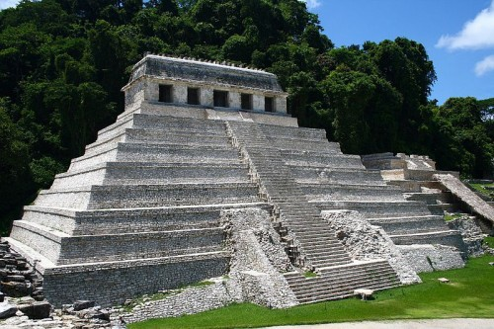
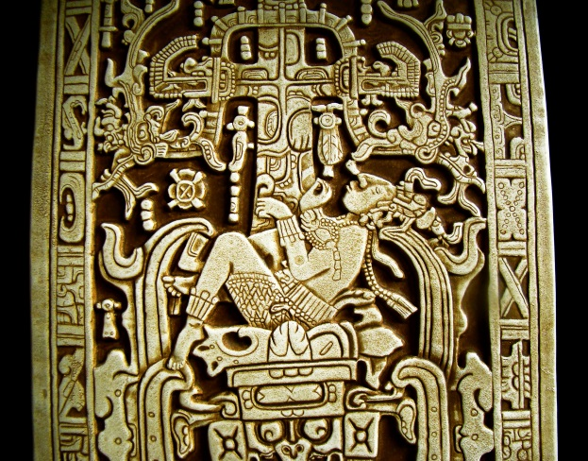
Covering the sarcophagus was a giant stone slab which, when removed, revealed the great king wearing a jade mask and adorned as the Maya Maize god in jade jewelry and a beaded net skirt. The tomb contained a great quantity of earrings, wristlets, bracelets, and necklaces. The abundance of jade shows how honored Pacal would have been to the Maya of Palenque, with the value of his jewelry and jade being estimated in the hundreds of millions of dollars.
The lid of the sarcophagus is perhaps one of the most debated Mesoamerican artifacts during the 1900s. Measuring 12 x 7 feet, it shows carvings of a man tilting backwards at the base of a tree, with a bird high at the top, either falling into or springing out of what appears to be a large urn. Glyphs and symbols run around the edges of the lid, all representing important parts of Mayan cosmology. The lid became well known worldwide when Erich Von Daniken published a book interpreting the picture as a man riding on a rocket ship, smoke issuing from an exhaust pipe behind him, and the glyphs representing outer space. Alien theorists immediately accepted the interpretation as proof that ancient civilizations had contact with extraterrestrial life forms. Since then, though, Mayan scholars have shown that it shows the World Tree, which the Maya believed connected the underworld, the living world, and the realm of the gods.
One final mystery exists, though, regarding the skeleton in the tomb. Most skeletons of Mesoamerica show significant teeth damage because of hygiene and gritty foods. The skeleton in the sarcophagus has very good teeth, estimated to be those of a man in his 40’s (Pacal would have been in his 80’s at death). Two theories exist about this mystery. First, as a nobleman Pacal would have had access to much better quality food, perhaps even softer food that would not have damaged his teeth like others in the area. He also would have had access to a personal physician to care for physical ailments, including tooth pain. The second theory proposes that the name on the tomb was not deciphered correctly, and thus it isn’t Pacal’s skeleton, but that of another younger nobleman. Because of these two mysteries and the extensive writing found at the Temple of Inscriptions, Palenque today is the most studied of the Maya cities.
Adapted from an article written by Joshua J. Mark http://www.ancient.eu/Kinich_Janaab_Pacal
Pacal
- Why is Pacal famous?
- What are the two longest Maya writings?

- What was Pacal wearing when he was buried? Why do you think he would have been wearing this?

- What is on the lid to Pacal’s sarcophagus?

- Is Pacal’s skeleton inside the tomb? Explain your answer.
Pacal
- Why is Pacal famous?
- What are the two longest Maya writings?

- What was Pacal wearing when he was buried? Why do you think he would have been wearing this?

- What is on the lid to Pacal’s sarcophagus?

- Is Pacal’s skeleton inside the tomb? Explain your answer.
Pacal
- Why is Pacal famous?
- What are the two longest Maya writings?

- What was Pacal wearing when he was buried? Why do you think he would have been wearing this?

- What is on the lid to Pacal’s sarcophagus?

- Is Pacal’s skeleton inside the tomb? Explain your answer.

