Pyramids in the Americas
Despite the towering reputation of Egypt’s Great Pyramids at Giza, the Americas actually contain more pyramid structures than the rest of the planet combined. Civilizations like the Olmec, Maya, Aztec and Inca all built pyramids to house their gods, in some cases to bury their kings. Temple-pyramids formed the center of public life and were the site of religious ceremonies, including human sacrifice. The best known Latin American pyramids include the Pyramid of the Sun and the Pyramid of the Moon at Teotihuacán, the Castillo at Chichén Itzá, the Great Pyramid in Tenochtitlan, the Pyramid at Cholula and the Inca’s temple at Cuzco.
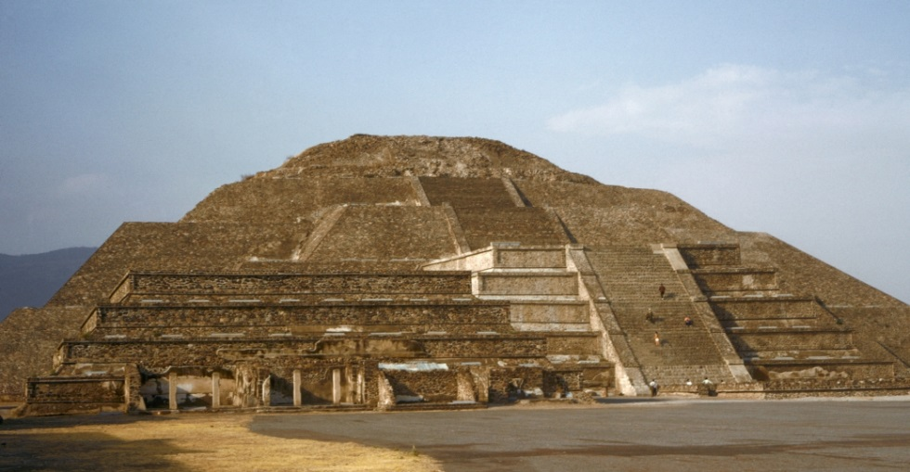
Mesoamerican peoples built pyramids from around 1000 B.C. up until the time of the Spanish conquest in the early 16th century. The earliest known pyramid stands at La Venta in Tabasco, Mexico. Built by the Olmecs, it dates to between 1000 B.C. and 400 B.C. American pyramids were generally built of dirt and then covered with stone, typically in a stepped, or layered, shape topped by a platform or temple structure.
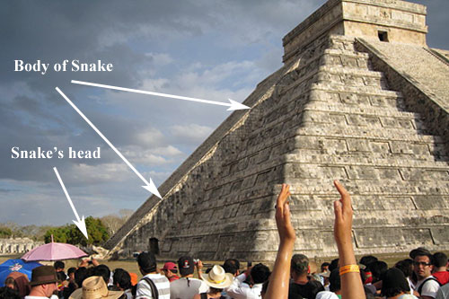
The most famous single pyramid in Latin America is the Pyramid of the Sun at Teotihuacán, Mexico. Located just a half an hour north of Mexico City, the pyramid is surrounded by additional smaller pyramids, including the Pyramid of the Moon. The pyramid is comparable to the Great Pyramid of Khufu in Egypt. It is believed that Teotihuacán was home to 100,000 to 200,000 people during the fifth and sixth centuries, making it one of the largest cities in the world at that time. More temples and pyramids have been discovered at Teotihuacán than in any other Mesoamerican city.
Maya Pyramids
The Maya, one of the largest civilizations of Mesoamerica, made temple-pyramids in the centers of their great stone cities. One of the most famous, the magnificently carved Temple of the Inscriptions at Palenque, was a tomb for the Mayan king Hanab Pakal. The tallest Maya pyramid, located in Tikal, Guatemala, is nearly 225 feet tall. The Maya city of Chichén Itzá contains the Castillo, or Temple of Kukulcan. This pyramid has many cosmological connections, including the snake that appears during the vernal and autumnal equinoxes and the 365 steps that correspond to our earth’s rotation around the sun.
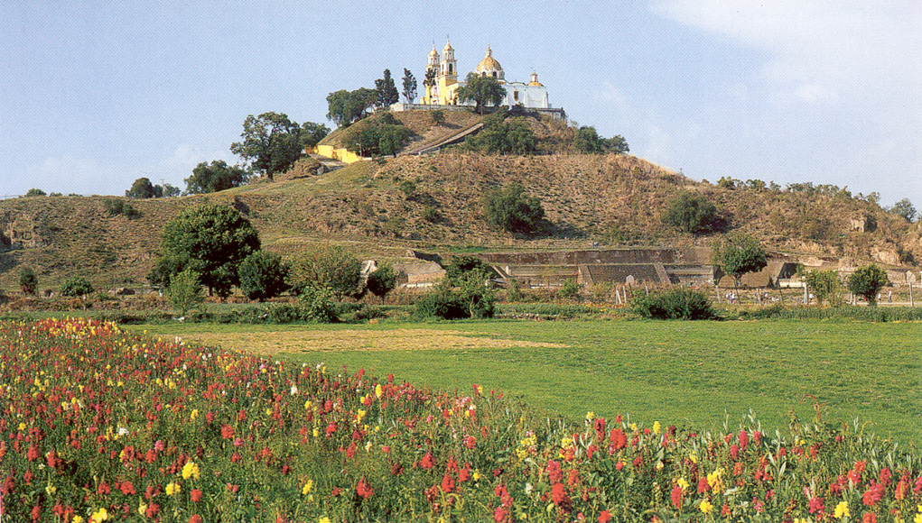
Aztec Pyramids
The Aztecs also built pyramids in order to house and honor their deities. The elaborate nature of Aztec pyramids and other architecture was also connected to the Aztec’s warrior culture: the Aztec symbol for victory was a burning pyramid, with a conqueror destroying the temple at its top. Many of the human sacrifices done by Aztecs were performed at the tops of these pyramids. Tenochtitlan, the great Aztec capital, housed the Great Pyramid, a four-stepped structure some 197 feet high. At its top, two shrines honored Huitzilopochtli, the Aztec god of sun and war, and Tlaloc, god of rain and fertility.
The pyramid complex of Cholula was the largest single structure in Mexico before the Spanish arrived. Constructed from adobe (sunbaked mud bricks), the Pyramid of Cholula measured 1,083 by 1,034 feet at the base and was about 82 feet high. The warrior Toltecs conquered the region around 1200, and rebuilt the pyramid as their ceremonial center. The Aztecs later claimed it as their own, dedicating it to the god Quetzalcoatl. When the Spaniards destroyed the holy city of Cholula in the 1500s, they built a Catholic church on top of the pyramid, symbolically claiming the New World for Christianity.
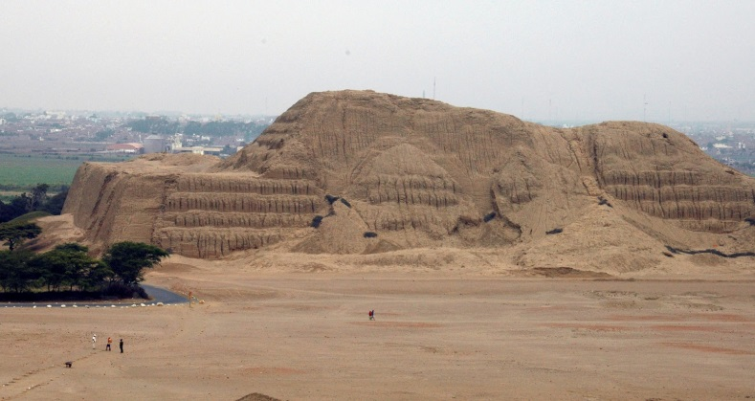
Pyramids to the South: Moche & Inca
More pyramids can be found in South America, including the Huaca del Sol (or Holy Place of the Sun). It was almost 100 feet tall and built of more than 143 million bricks, while the Huaca de la Luna (dedicated to the moon) was rebuilt multiple times over a 600-year period.
Inca ruler Pachacuti began the construction of a great temple-pyramid, Sascahuamán, in the capital city of Cuzco. It took 20,000 workers 50 years to build the pyramid, constructed from huge stones fitted together without mortar.
Did You Know?
In many cases, pyramids in Latin America were rebuilt again and again over the top of already existing structures, in order to glorify the current ruler. Rebuilding the pyramid, it was believed, was a crucial process that renewed the king's relationship with the gods.
At one point, historians concluded that American pyramids were not intended as burial chambers but as homes for the gods. However, more recent excavations have unearthed evidence that some pyramids did include tombs, and there is also evidence that city-states used the pyramids for military defense.
Adapted from http://www.history.com/topics/ancient-history/pyramids-in-latin-america
Pyramids in the Americas
- T/F: There are more pyramids in Egypt than the Americas.
- What would the Aztecs do at the top of their pyramids? How does this connect to the Aztec symbol for victory?

- How many million brick are in the Huaca del Sol?

- Why did the Spanish build a church on top of the Cholula pyramid?

- What were many American pyramids built on top of?
Pyramids in the Americas
- T/F: There are more pyramids in Egypt than the Americas.
- What would the Aztecs do at the top of their pyramids? How does this connect to the Aztec symbol for victory?

- How many million brick are in the Huaca del Sol?

- Why did the Spanish build a church on top of the Cholula pyramid?

- What were many American pyramids built on top of?
Pyramids in the Americas
- T/F: There are more pyramids in Egypt than the Americas.
- What would the Aztecs do at the top of their pyramids? How does this connect to the Aztec symbol for victory?

- How many million brick are in the Huaca del Sol?

- Why did the Spanish build a church on top of the Cholula pyramid?

- What were many American pyramids built on top of?

