Ten Innovations that Built Ancient Rome
Concrete
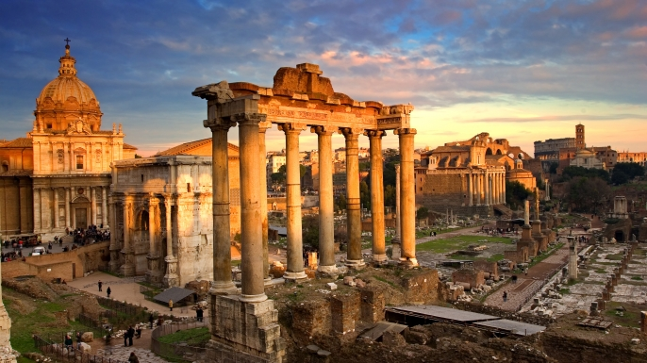
Many ancient Roman structures like the Pantheon, the Colosseum and the Roman Forum are still standing today thanks to the development of Roman cement and concrete. The Romans first began building with concrete over 2,100 years ago and used it in everything from aqueducts and buildings to bridges and monuments. Roman concrete used slaked lime and a volcanic ash known as pozzolana to create a sticky paste. To these two ingredients they added a volcanic rock called tuff, which formed a concrete that has lasted for centuries. Pozzolana helped Roman concrete solidify quickly (even when submerged in seawater) allowing Romans to build elaborate baths, piers and harbors right in the water.
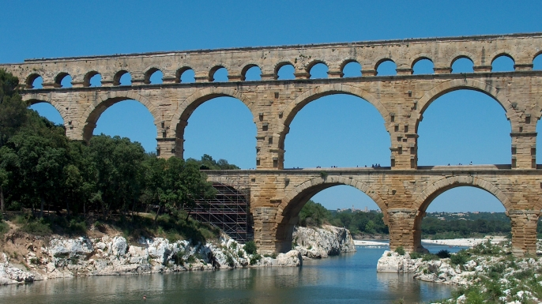
Aqueduct
The Romans developed public toilets, underground sewage systems, fountains and decorative public bathhouses. None of these innovations would have been possible without the Roman aqueduct. First developed around 312 B.C., aqueducts used gravity to transport water along concrete pipelines and into city centers. Aqueducts allowed Roman cities to be built anywhere (not necessarily next to a river for fresh water) and improved public health and sanitation. Some Roman aqueducts transported water from as far as 60 miles away! Perhaps most impressive of all, Roman aqueducts were so well built that some are still in use to this day. Rome’s famous Trevi Fountain, for instance, is supplied by the Aqua Virgo, one of ancient Rome’s 11 aqueducts.
Newspapers
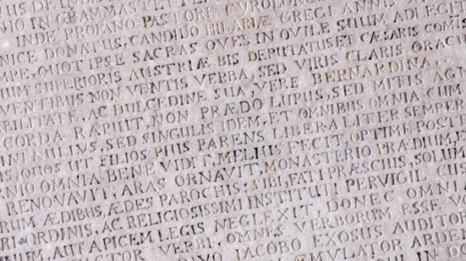
The Romans informed the people through official messages about military, legal and civil issues using Acta Diurna, or “daily acts.” These early newspapers were written on metal or stone and then posted in the city centers. Acta typically included details of Roman military victories, lists of games and gladiatorial fights, birth and death notices and other stories. There was also an Acta Senatus, which told what was happening in the Roman senate.
Welfare Programs
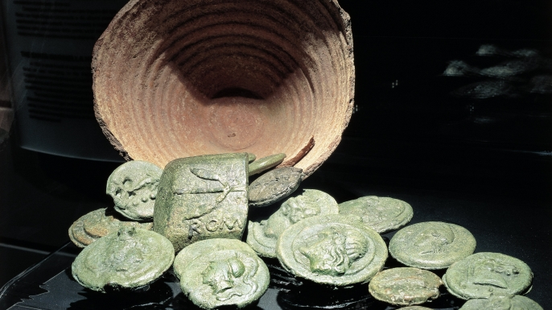
Ancient Rome was the source for many modern government programs, including programs that help with food, education, and housing for poor citizens. The Roman emperor Trajan started a program known as “alimenta” which provided food, clothing, and education for orphans and poor children. Individuals who needed such help would turn in a metal token called a “tesserae” and receive corn, oil, bread, wine, or pork in exchange. These generous handouts helped Roman emperors become popular with the public, but some historians believe that they also contributed to Rome’s economic decline.
Bound Books
For most of human history, people wrote on clay tablets (like the Mesopotamians) or scrolls (like the Chinese and Egyptians). The Romans simplified the storage of such writings by creating the codex, a stack of pages joined by a cover. The first codices (plural form of codex) were made of wax or animal skin, but eventually took the book form we use today. Early Christians became some of the first to adopt the new technology, using it to produce copies of the Holy Bible.
Roads
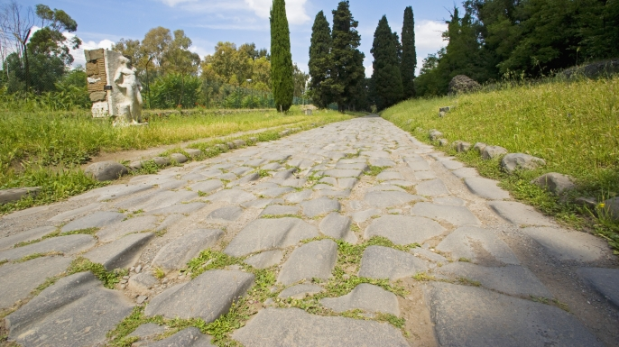
Like the Inca, the Romans needed to communicate with a large empire. To accomplish this, they developed the most sophisticated system of roads the ancient world had ever seen. These Roman roads were constructed with a combination of dirt, gravel and bricks made from granite or hardened volcanic lava. Roman engineers adhered to strict standards when designing their highways, creating arrow-straight roads that curved to allow for water drainage. The Romans built over 50,000 miles of road by 200 CE, primarily for troops to move from one place to another. Highways allowed the Roman legion to travel as far as 25 miles per day, and mail messages could be relayed with astonishing speed. These roads were often managed in the same way as modern highways. Stone mile markers and signs informed travelers of the distance to their destination, while special soldiers acted as a kind of highway patrol.
Arches
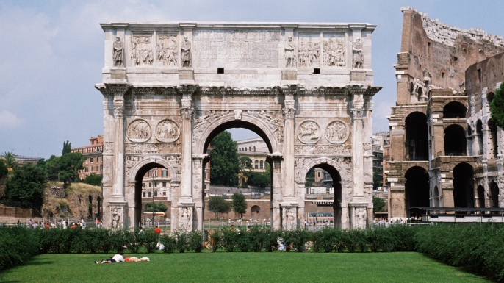
Arches have existed for roughly 4,000 years, but the ancient Romans were the first to effectively use them in the construction of bridges, monuments and buildings. The brilliant design of the arch allowed the weight of buildings to be evenly distributed, preventing huge Roman structures like the Colosseum from crumbling under their own weight. Along with columns, domes and vaulted ceilings, the arch became one of the defining characteristics of the Roman architectural style.
Calendar
The modern Gregorian calendar is based on a Roman version that dates back more than 2,000 years. Early Roman calendars were likely made from the Greek calendar that followed the lunar cycle. However, because the Romans considered even numbers unlucky, they changed the calendar to make sure that each month had an odd number of days. This practice continued until 46 B.C., when Julius Caesar and the astronomer Sosigenes instituted a new calendar that mathematically fit the solar year. Caesar lengthened the number of days in a year from 355 to the now-familiar 365 and eventually included the 12 months as we know them today. The Julian calendar was almost perfect, but it miscalculated the year by 11 minutes. To fix this error, the Gregorian monks proposed a revised form of the Roman calendar in 1582, which fixed the problem by adding in leap years.
Roman Law
Subpoena, habeas corpus, pro bono, affidavit—all these terms are used by lawyers in the United States today. They all come from the Romans, who used something called the Twelve Tables. First adopted around 450 B.C., the Twelve Tables gave laws about property, religion and divorce and listed punishments for everything from theft to black magic. In 535 CE the emperor Justinian wrote the Corpus Juris to replace the Twelve Tables, and included the idea that someone is innocent until proven guilty. After the fall of the Roman Empire, this idea became the basis for many of the world’s legal systems.
Battlefield Surgery
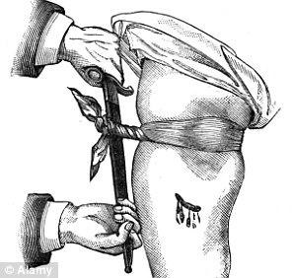
The Romans invented many surgical tools and were the first to use cesarean section, but their most valuable contributions to medicine came on the battlefield. Under the leadership of Augustus, they established a military medical corps that was one of the first battlefield surgery units. These specially trained medics saved countless lives through the use of Roman medical innovations like tourniquets to stop bleeding. Roman field doctors also checked new recruits to make sure they were ready for combat and made sure soldiers practiced good hygiene in camp. They were even known to disinfect instruments in hot water, a process to kill bacteria that was not fully embraced until the 19th century. Roman military medicine proved so advanced at treating wounds and promoting wellness that soldiers tended to live longer than the average citizen despite constantly facing the dangers of combat.

Ten Innovations that Built Ancient Rome
- What are the three ingredients of Roman concrete?

- How did aqueducts benefit Roman cities?

- What were the Acta Diurna and Acta Senatus used for?

- What was a Roman tesserae used for?

- Why would Romans use books instead of scrolls or clay tablets?

- Why did Roman roads allow for soldiers and messengers to move more quickly?

- How does the Roman arch work?

- Why did the Gregorian monks have to fix Julius Caesar’s calendar?

- How does the Corpus Juris affect you today?

- True/False Roman soldiers usually lived longer than average citizens because of Roman military doctors.

