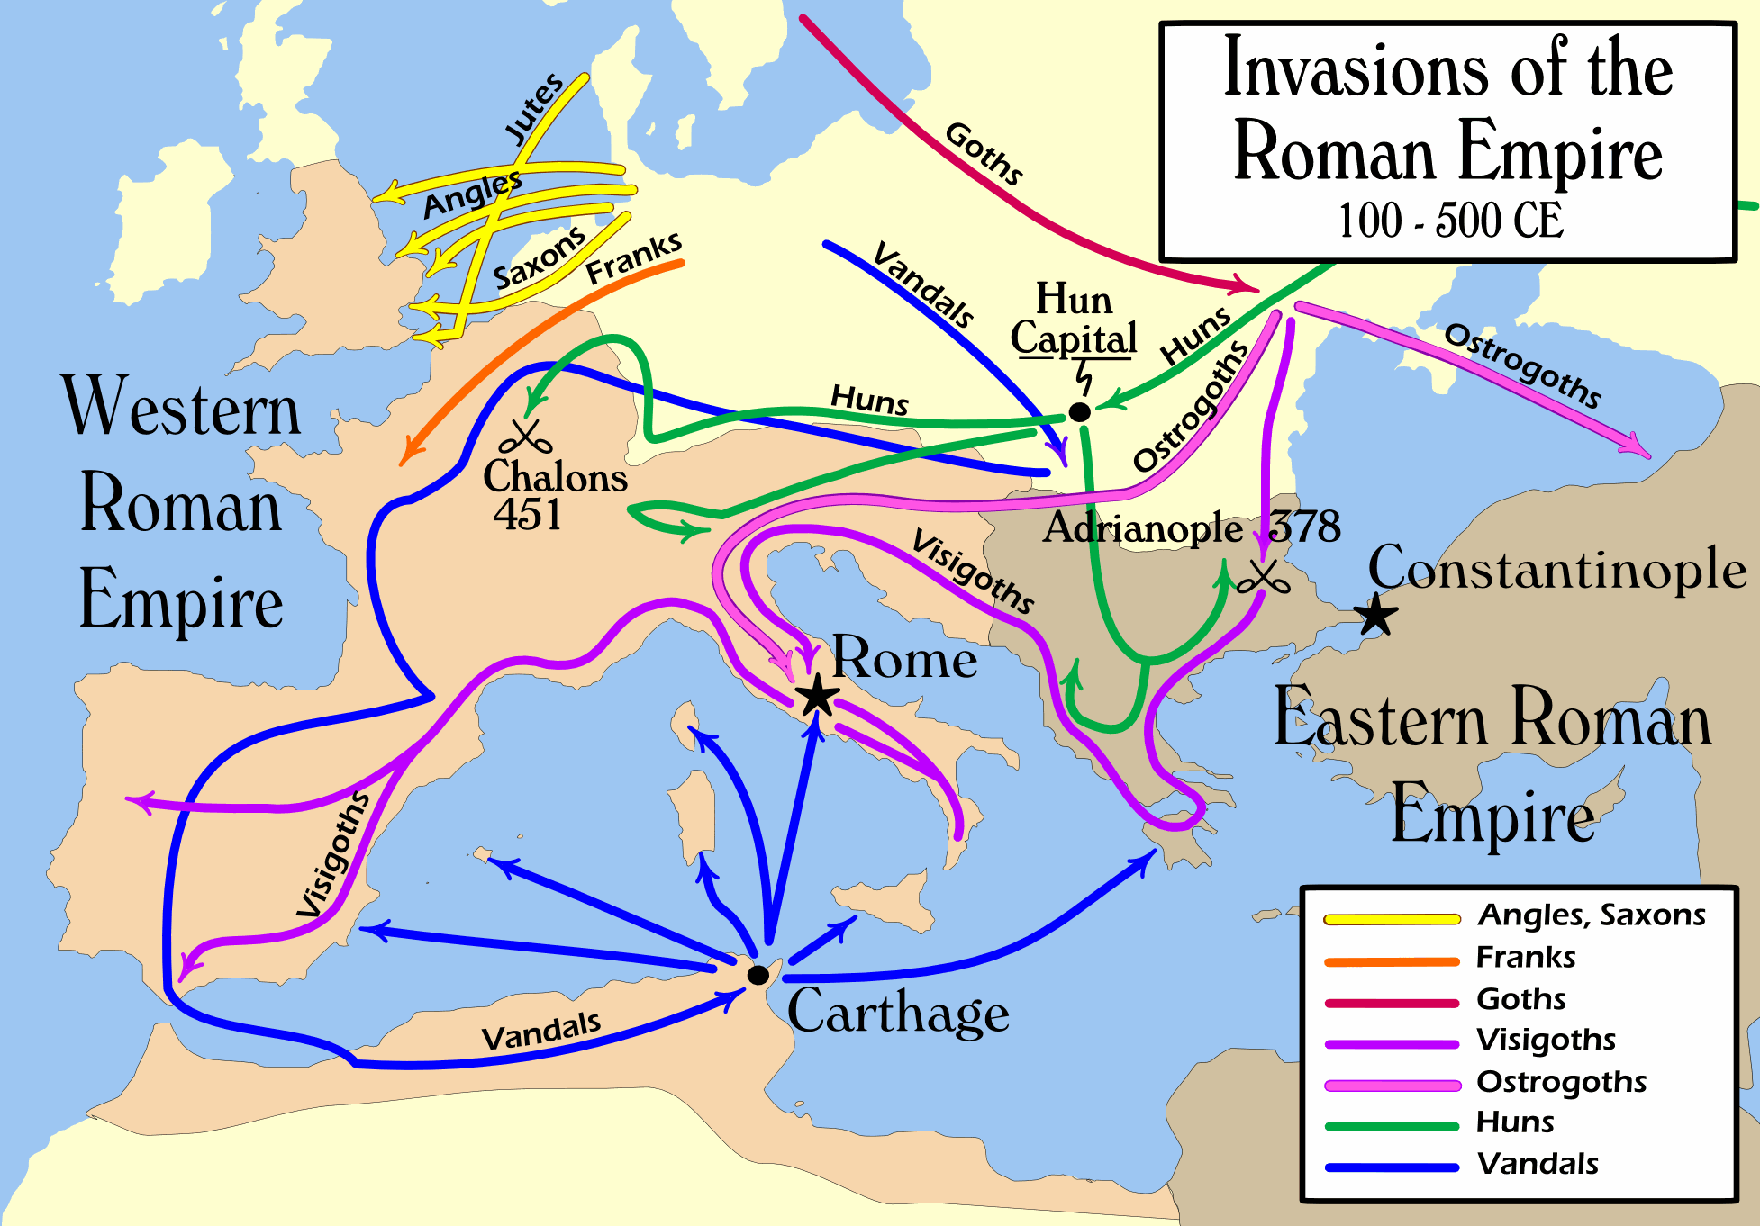

Barbarian Invasions

Barbarian: any member of the tribes who lived in Germany, considered by the Romans as uncivilized and primitive

For years the well-disciplined Roman army held the tribes of Germany (known as barbarians) under control, protecting Rome from invasion from the north. However, political arguing inside the capital city caused multiple civil wars, allowing consuls and generals to exhaust the empire’s resources and troops while fighting against itself. In the third century A.D. Roman legionnaires were asked to come back to Rome to help end the civil wars in Italy, leaving the northern Roman border open to attack. German barbarians soon took back Roman lands that had once belonged to them, and in A. D. 476 the Germanic general Odovacar invaded Rome and made himself the ruler of all Italy. From this point on, Germanic tribal chiefs ruled the western part of the Empire. Without the political training of former Roman leaders, these barbarians allowed the organized roads to crumble into disrepair and many fertile fields were left untended, covered with weeds instead of crops. Barbarians had little motivation to expand the empire, and so troops did not patrol the roads. The guarantee of safety on Roman roads was left unfulfilled and pirates and bandits were allowed to attack travelers. Merchants who chose to send their trade goods along the roadways found them frequently stolen, leading to businesses to stop sending their shipments to distant cities. Without Roman goods, distant cities crumbled and the empire was lost.

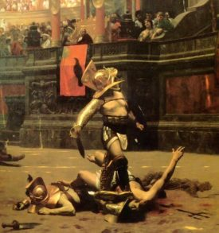
Decline of Morals and Values

Morals: A belief in high behavior (examples might include the desire to obey the law, to help poor citizens, or to be honest)

The final years of the Empire were marked by a decline in morals and values. Following the murder of Julius Caesar, it became common for emperors to be assassinated by members of the political elite of Rome. Often these murders went unpunished. This led to an increase in violent crimes in the streets of Rome, where it became common to be mugged or attacked. Emperors like Nero and Caligula became known for wasting money on enormous parties, where guests ate and drank until they became sick. The most popular entertainment of Rome during this period was watching the gladiatorial combats in the Colosseum. All social classes of people attended these shows, with the most graphic battle scenes gaining the most cheering. Multiple gladiator events would be held on the same day. If the arena became too soaked with blood, a new layer of sand would be spread on top so the bloody performances could go on. With so much violence, crime, and thievery the Roman empire collapse from a lack of self-control.

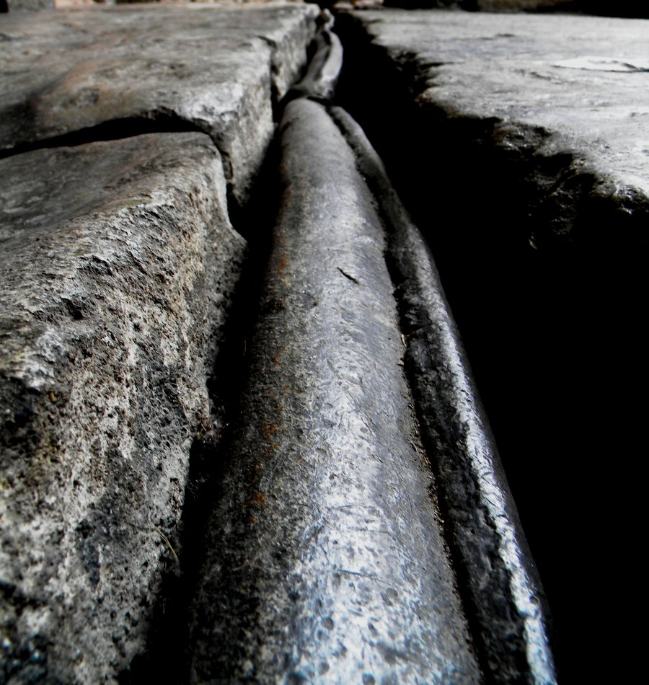
Environmental and Public Health Problems

Lead poisoning: a medical condition where too much lead is consumed, which causes seizures, birth defects, and even some forms of insanity.

Some historians believe that the fall of the Roman Empire was because of health and environmental problems. Rome grew to become the world’s largest city in the year 1 A.D. because of the aqueducts and sewers, yet the lead pipes that brought water to homes may have had negative consequences. Since only the wealthiest of Romans could afford to have lead pipes bringing water to their homes, the wealthiest were also those in leadership positions. As water passed through the lead pipes, excessive amounts of lead became accumulated in the water, leading to a large percentage of lead poisoning cases with the wealthy of Rome. This lead was common in drinking and bathing water, and was also in their food from the lead cooking tools used to prepare the meals. Excessive amounts of lead also could lead to some forms of insanity, perhaps explaining the poor choices made by many of Rome’s elite.

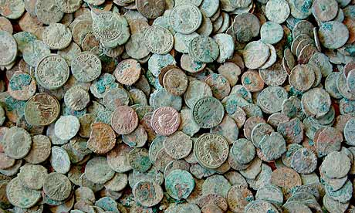
Excessive Costs to Defend the Empire/High Taxes

Mercenary: Someone hired to fight in the army, usually only there because of the money and not because they care who wins
Bankruptcy: A condition where one cannot pay bills and has personal property taken away by the bank

Keeping an army well supplied is expensive. For the Romans, keeping an army large enough to protect all sides of the empire was very expensive. To pay for such an army, the Roman leaders were constantly raising taxes. Without money to spare for improving education or even maintaining roads, Rome began to fall apart from the inside. This left few Romans willing to join the army and fight for their empire. To continue to provide protection for Romans, the leaders had to hire mercenaries to defend against attacks. However, these mercenaries had little loyalty to Rome and were extremely expensive. In time, businessmen and farmers were the main taxpayers and quickly were forced into bankruptcy, leaving no money to pay mercenary armies to protect Rome. Invading barbarians easily pushed aside any armies and sacked Rome.

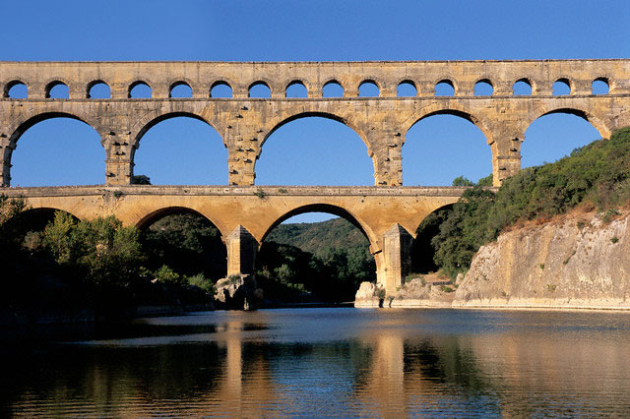
Inferior Technology

Inferior: not as good as another, less than or worse in quality (means the opposite of superior)

During the early years of the Romans, any useful technologies were adopted from neighboring civilizations (Mesopotamians, Egyptians, Greeks, etc). Using the best of every earlier civilization helped Rome to grow quickly. During the last 400 years of the Empire, however, Romans didn’t invent many new technologies. Their empire was based on military control, which required large numbers of troops. They also needed laborers to grow food and had little time to create new ways to solve old problems. Roman political success was based on military success, not on the amount of education one received. As a result, Romans became so occupied with fighting they were too busy to think. Ultimately, the Empire needed so many laborers they were unable to provide enough food for the troops or the common citizen, leading to starvation and revolt. Without time or educated individuals to invent new solutions for their new problems, the empire fell.

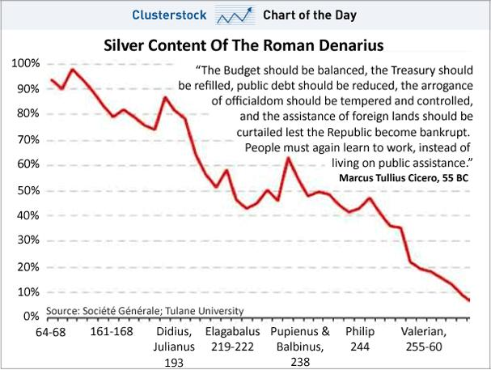
Inflation

Inflation: A natural process of money losing value over time, or an increase in prices of goods available for sale

After the reign of Marcus Aurelius, the Roman economy suffered from inflation. This was due to the end of military expansion, which meant that new gold stopped flowing to Rome from the conquered territories. With less time fighting, people started spending more. Without more new gold coming to Rome and with Romans spending more in peacetime, there was less gold to use for coins. Romans started using less gold in their coins by mixing it with other metals, which made the coins less valuable. To make up for this loss in value, the merchants increased the prices on the goods they sold. Many people stopped using coins and began to barter (trading goods rather than using money) to get what they needed. Eventually salaries had to be paid in food and clothing and taxes were collected in fruits and vegetables. Over time, goods became too expensive for most people to afford, and poverty became common. With poverty came many frustrations and civil wars, leading to the end of the Romans.

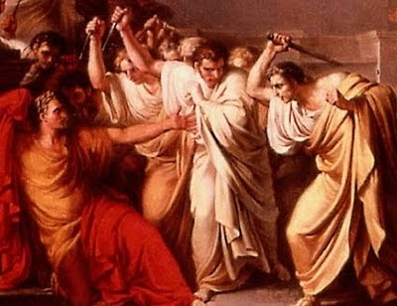
Political Corruption

Corruption: dishonest or fraudulent behavior by those in authority, often through bribery.

One of Rome’s most serious problems was choosing new emperors. The Romans had never created an effective system to determine how the new emperors were to be selected. For this reason, the choice of a new emperor was always be open to debate between the old emperor, the regular army and the emperor’s private army called the Praetorian Guard. The newly elected emperor would highly reward those who had chosen him. This system worked fine for a while, but later, after 186 A. D, the practice of selling the throne to the highest bidder made it difficult to have good rulers. In fact there were 37 different emperors during a 100-year period – with 25 of them being removed from office by assassination. New emperors were often poor leaders—only in power because they had paid others for their support. With poor leadership that changed frequently, the Roman Empire was unable to solve the problems that came with such a large civilization.

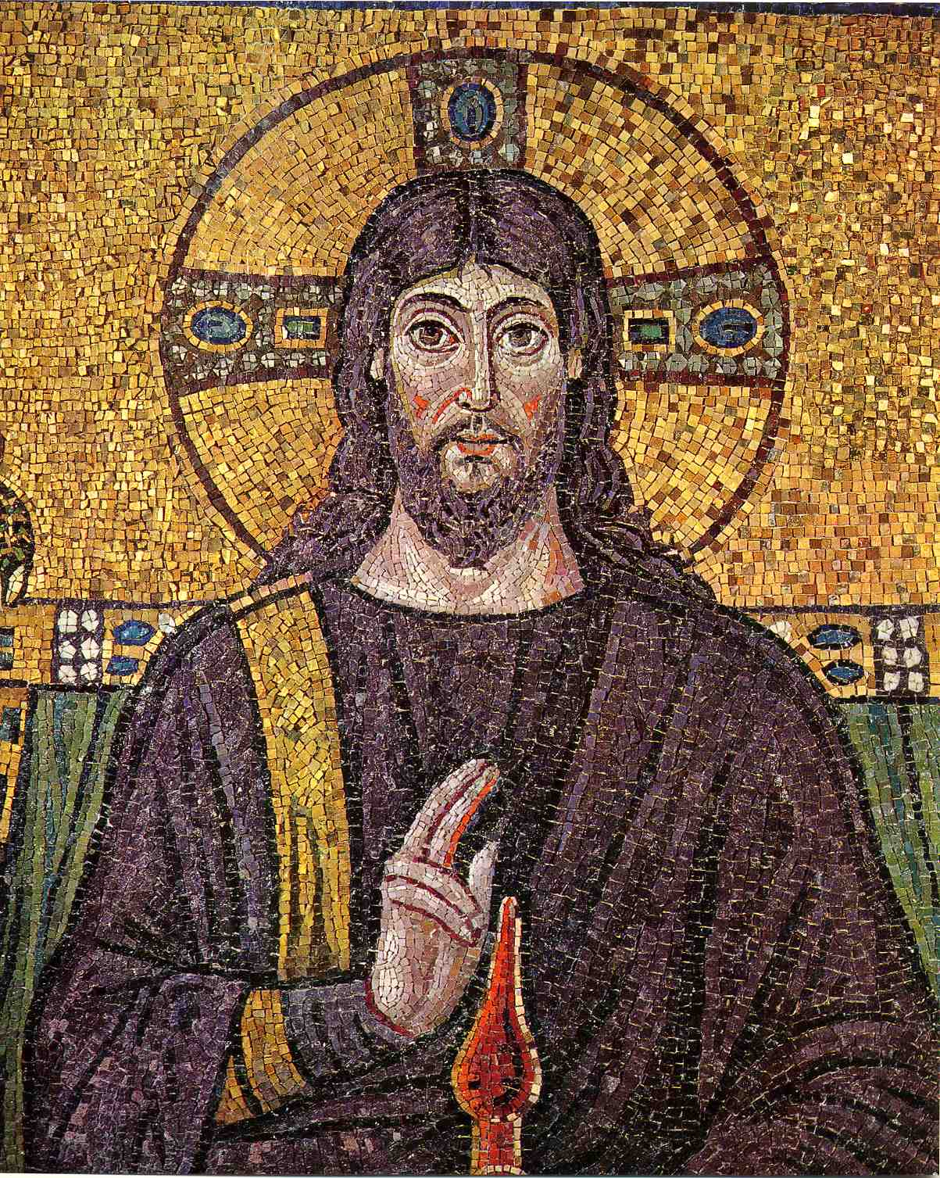
Rise in Christianity

Christian: A follower of Christ, who taught that all should love one another

In the beginning, Christians were persecuted and blamed for the problems of Rome. Over time, however, the empire accepted Christianity (the emperor Constantine even became a Christian himself!). With this rise of a new religion, many supported the teachings of Christ and shouted for kind treatment of all. These Christians even opposed going to war against barbarians, making it difficult to defend from the barbarian attacks. As the religion grew, so did the church positions that led the Christians. These church leaders gradually took power away from the nobles of Rome, leading the people to follow them instead. Since the people followed their church leaders, the Roman political leaders lost power over the people. In addition, the Christian leaders encouraged the people to give money to build more churches, cathedrals, and monasteries, leading to a shortage of funds for the empire to defend itself. Rome was ultimately attacked and defeated by non-Christian barbarians.

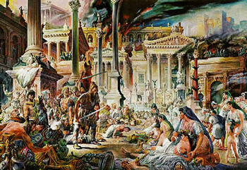
Unemployment

Unemployment: where one does not have a job and often cannot find a job

During the last years of the Empire, farming was done on large farms that were owned by wealthy men. To run these farms, the wealthy landowners used slave labor. Since they did not need to pay their slaves to work, they could produce food more cheaply than those who hired workers to farm. As a result, farmers without slaves could not compete with the slave owners and had to sell their lands to pay their taxes. Without land, these farmers were now without any way to earn money. They joined the large numbers of unemployed in Rome, demanding free food promised to the poor. Since businesses were closing all over Rome, there were no new jobs available. At one point, there were more than 100,000 unemployed people just in the city of Rome, all demanding that the emperor keep his promise of providing tesserae for the poor. Thousands of tons of grain had to be bought to feed the masses, but the lack of farmers meant the emperor had to buy food from other civilizations at high costs, which drained the treasury. Rome had no money and ran out of food, leaving the army unable to defend Rome from invasion.

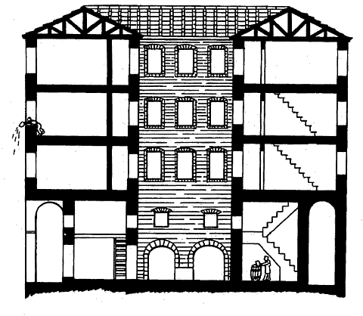
Urban Decay

Urban: large cities, not rural
Decay: falling apart, breaking down, disintegrating

Wealthy Romans lived in fancy houses called a domus. These houses had marble walls, floors with intricate colored marble tiles, and windows made from real glass. However, most of the people of Rome were not rich. The others lived in small, smelly rooms in apartment houses with 6 or more rooms called islands. Each island covered an entire block. At one time there were more than 44,000 apartment houses with in the city walls of Rome. The poor did not occupy first floor apartments, as the rent was too high. As the people climbed up the shaky wooden stairs to the higher-level dwellings, the rent was cheaper, and the apartments became warmer, darker, and more crowded. Anyone who could not afford to pay the rent was forced to move out and live on the crime infested streets. Because so many people lived on the streets, the cities began to decay. The wealthy people of Rome didn’t care if there were poor people, even when the large apartments started to fall down or burn.

Name________________________
Ten Theories on the Fall of Rome  - Excessive: |  | Summary of the Theory
Barbarian invasion
- Barbarian:

Decline of morals and values
- Morals:

Environmental problems
- Lead poisoning:

Taxes and military spending
- Mercenary:

- Bankruptcy:

Inferior technology
- Inferior:

Inflation
- Inflation:

Political corruption
- Corruption:
Rise of Christianity
- Christianity:

Unemployment
- Unemployment:

Urban decay
- Urban:

- Decay:

